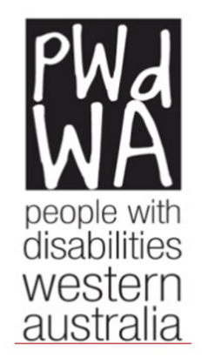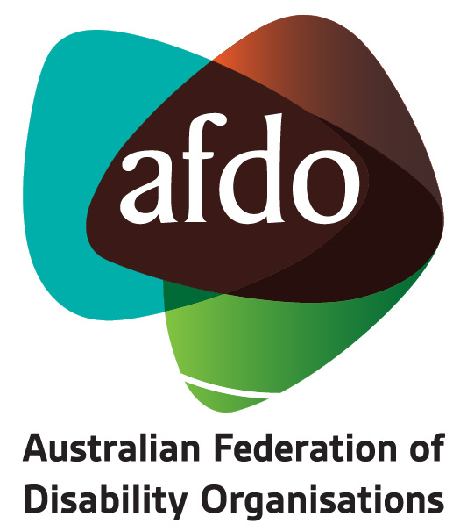

Response to Subsequent Questions from the
Joint Select Committee
– End of life Inquiry
Western Australia

23rd April 2018
Contents
People with disabilities WA (PWdWA) 3
Australian Federation of Disability Organisations 4
Subsequent Questions – Advance Care Planning 5
Question 12. In your view is there a need for more community education about AHDs and Enduring Powers of Guardianship (EPGs)? 5
Question 13. Do people with disabilities raise concerns with you regarding whether or not their wishes are followed by healthcare professionals in accordance with their AHD? 7
Question 14. In your experience are healthcare professionals aware of the law in relation to AHDs, EPGs and the hierarchy of substitute decision‐makers? 7
Question 15. You have indicated that an advance care directive should not be used to request voluntary assisted dying in contrast to a refusal of life sustaining medical treatment. Would you please explain your reasoning for this? 8
Contact details; 9

People with disabilities WA (PWdWA)
Since 1981 PWdWA has been the peak disability consumer organisation representing the rights, needs, and equity of all Western Australians with a physical, intellectual, neurological, psychosocial, or sensory disability via individual and systemic advocacy. We provide access to information, and independent individual and systemic advocacy with a focus on those who are most vulnerable.
PWdWA is run by and for people with disabilities and aims to empower the voices of all people with disabilities in Western Australia.

Australian Federation of Disability Organisations
The Australian Federation of Disability Organisations (AFDO) is the peak organisation in the disability sector representing people with lived experience of disability. AFDO and its member organisations are run by and for people with lived experience of disability.
AFDO’s mission is to champion the rights of people with disability in Australia and support them to participate fully in Australian life. AFDO has strong relationships not just with its member organisations, but across the disability sector including peaks representing service providers as well as those representing families and carers.
As a founding member of the National Disability and Carer Alliance, AFDO played a key role in the campaign for the introduction of the National Disability Insurance Scheme (NDIS). As the NDIS has moved through the trial phase and begun the transition to full scheme, AFDO and its members have continued to work constructively with the National Disability Insurance Agency (NDIA) as well as Commonwealth and State and Territory governments to provide critical feedback and address implementation issues as they arise.
AFDO’s members include:

Blind Citizens Australia
Brain Injury Australia
Deaf Australia
Deafblind Australia
Autism Aspergers Advocacy Australia
Down Syndrome Australia
Physical Disability Australia
Disability Advocacy Network Australia
Disability Justice Advocacy
People with Disability WA
Disability Resources Centre
Inclusion Australia (NCID)
People with Disabilities ACT
Women with Disabilities Victoria
Enhanced Lifestyles
Deafness Forum of Australia

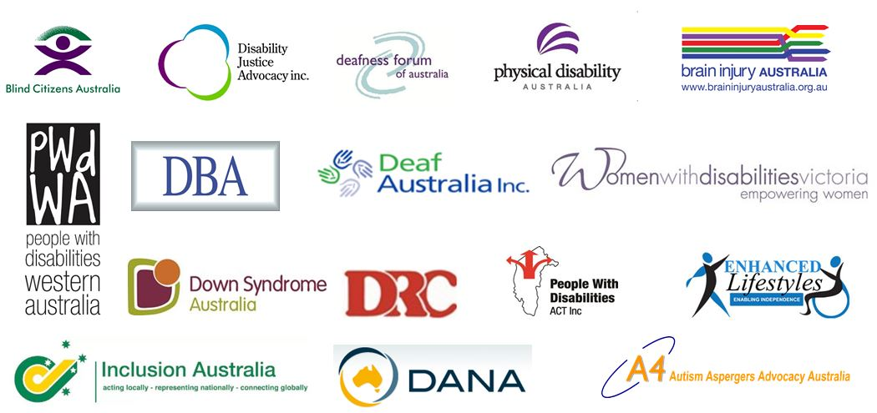

Subsequent Questions – Advance Care Planning
Please note: In our responses we take the terms Advanced Health Directive (AHD) and Advanced Care Directive (ACD) to be interchangeable.

Question 12. In your view is there a need for more community education about AHDs and Enduring Powers of Guardianship (EPGs)?
AFDO and PWDWA would always support the education of the community, particularly the disability community, about mechanisms that provide people with disability with choice and control such as advance care directives or advance statements or Enduring Powers of Attorney.
The Western Australian Office of the Public Advocate Community Education Program is available to the public and is free:

http://www.publicadvocate.wa.gov.au/C/community_education_training.aspx?uid=7662-1142-1340-2752

The Victorian Office of the Public Advocate run a community education program from their office inclusive of:
- enduring powers of attorney
- medical treatment decision making
- guardianship and administration
- advance care planning

The Community Education Program is available to the public and is free and widely accessed, see:
http://www.publicadvocate.vic.gov.au/our-services/community-education
Another example for the consideration of the Inquiry relates to the use of Advance Statements contained in the Victorian Mental Health Legislation. Community Education around Advance Statements is undertaken by mental health advocacy organisations and legal agencies such as the Mental Health.
Below are some examples of community education around Advance Statements in the Mental Health space in Victoria and their application
https://www.vmiac.org.au/wp - content/uploads/2017/02/vmiac_guide_to_advance_statement.pdf

http://www.communitylaw.org.au/mentalhealth/cb_pages/living_wills.php
The following extract is from the Victorian Government publication “Advance Statements Under the Victorian Mental Health Act”

“Having an Advance Statement means your doctors and treating team must consider your treatment preferences in your Advance Statement. Advance Statements are helpful because:
• They express your wishes about treatments you want or do not want. This might include certain medications or electro convulsive therapy (ECT). For example, you might know what treatments work well for you when you are unwell, and what treatments have unwanted side effects.
• An Advance Statement provides you with an opportunity to say why you have these preferences so that your views and preferences are more clearly understood.
• Preferences that do not relate to treatment such as arrangements for looking after children or pets, finances or other matters are also important to acknowledge. These can be documented in an Advance Statement, as ‘additional information’, or in a separate document containing information the person feels would be useful to the treating team while they are under compulsory treatment. See the example of a template (later in this document) for more information.
• It gives you the chance in advance to talk about the treatment you would like with your family members, friends, nominated person or treating team. This can help important support people to understand what treatment you would like. They will then be in a better position to make sure your preferences are heard, understood and considered if you become unwell.”
“What is the difference between an Advance Care Directive and an Advance Statement? An Advance Care Directive comes into effect when a person is unable to make decisions about medical treatments other than mental health. For example when someone has dementia, an acquired brain injury or is unconscious. Advance Statements relate to treatment provided in the context of being cared for under the Mental Health Act.”

Question 13. Do people with disabilities raise concerns with you regarding whether or not their wishes are followed by healthcare professionals in accordance with their AHD?
In their advocacy role, PWDWA has not had any issues where people have raised concerns about an Advanced Health Directive not being followed. However, we have also not had any issues to do with advanced health directives at all. We do know that people often have issues with healthcare professionals not being as vigorous in their investigation of health issues and our concern is similar in that their wishes may not be taken as seriously as a person without a disability.

We also quite regularly advocate on behalf of people with a disability who are challenging a guardianship or administration order or directive from a Guardian. The guardianship laws and processes have been in place for many years and we know that people are given information about their rights and their right to seek an advocate to assist them if they don’t agree with what is happening.
Advanced Health Directives are still relatively new and are not being taken up or necessarily well understood by very many people with disabilities or with mental health issues yet. It is also not clear if there is information given about advocacy, and at what point information might be given about a person having access to an advocate if they wish to challenge or change what may have already been agreed in an Advanced Health Directive.

Question 14. In your experience are healthcare professionals aware of the law in relation to AHDs, EPGs and the hierarchy of substitute decision‐makers?
From the perspective of AFDO, representing the voice of disability, a general observation is that the healthcare system is not accessible for people with disability nor do people with disability experience equitable outcomes. It can be assumed from this evidence that healthcare professionals are generally unaware of the law as it applies. However, it is assumed that they may be more aware of the law as it relates to AHD’s and EPG’s than other professions.
A lack of access and equitable healthcare outcomes was outlined comprehensively in the PWDWA / AFDO Submission to the Inquiry. Most recently in March 2018, evidence of this was provided to a National Roundtable on Mental Health and Intellectual Disability by Dr Julian Trollor Chair, Intellectual Disability Mental Health / Head, Department of Developmental Disability Neuropsychiatry Professor, School of Psychiatry | UNSW Medicine where it was reported that People with Intellectual Disability (ID) experiences in the health system;
- 5 times more likely to experience ultra long hospital stays (>365 days);
- 2 times as likely to be admitted > 3 times a year
- 3 times the risk of presenting to the emergency department
- Are 55-75% higher likelihood of being readmitted
- Have non uniform access to GPs
- Have over‐representation of presentations for psychological reasons
- Have administrative rather than medical needs dominating their GP encounter
- Have much higher rates of psychotropic medication recommendations e.g. 10 fold for antipsychotics
- Have less attention to preventative health needs and preventative prescribing
It is from this context that AFDO would make the observation that given the lack of general and specific understanding of disability in the healthcare sector there is an equivalent and generalised lack of understanding about decision making mechanisms such as Advance Care Directives and Enduring Powers of Guardianship as they apply to people with disability in a healthcare setting.
In Western Australia the Disability Health Network is working to address the issues of understanding of disability within the healthcare system and has developed a number of resources and engaged with the health sector. However at this point in time it is unclear how this work might directly translate to understanding about how AHD’s and EPG’s can be used in the context of a person with a disability.

http://ww2.health.wa.gov.au/Articles/A_E/Disability-Health-Network

Question 15. You have indicated that an advance care directive should not be used to request voluntary assisted dying in contrast to a refusal of life sustaining medical treatment. Would you please explain your reasoning for this?
PWdWA and AFDO support the conclusion offered by the Victorian Ministerial Advisory Panel that “there is a fundamental difference between refusing lifesaving medical treatment in an advance care directive and requesting voluntary assisted dying”.PWdWA and AFDO believe that an advance care directive should not be used to request voluntary assisted dying.
Advance Care Directives provide a mechanism to look into the future and set out what your wishes would be as you move towards that future. A good example may be what treatment you would wish to have or not have and under what circumstances you wish that treatment to be provided or not provided. It is essentially a guide to your wishes, constructed in the present, but looking toward the future. A future in which the person may feel very different given the circumstances they find themselves in, and their reactions to those circumstances. It can outline the circumstances in which the Advance Care Directives would become live such as becoming seriously unwell.
For example, many people say that should they become incapacitated through illness in the future they would not wish to continue to live. However, people may change their minds once in such circumstance and although they become incapacitated they decide, at that point, that want to continue to live. They may discover they have a fighting spirit they did not know they possess. Life experiences over the intervening period may have changed the way they feel about being incapacitated and result in a change in their thinking about that circumstance.
Accepting this idea, it is vital for the integrity of a voluntary assisted dying program that such a decision is made in the present when the circumstances of dying are happening to you. The circumstances have to be current and the decision related to those circumstances must also be current.
Making a decision to request voluntary assisted dying is so significant that it can only be undertaken at the time in the circumstances of a terminal illness. The ‘as it happens’ nature of this decision acts as one more check and balance in this most vital of decisions. This is why a request for voluntary assisted dying cannot be inserted into an Advance Care Directive.

Contact details;
People with Disabilities (WA) Inc. (PWdWA) and the Australian Federation of Disability Organisations (AFDO) would like to thank the Western Australian State Parliament for inviting our organisations to provide further responses to the Inquiry.
PWdWA

Executive Director: Samantha Jenkinson
Email: samantha@pwdwa.org Tel: (08) 94858900

People with Disabilities (WA) Inc.
Oasis Lotteries House, 1/37 Hampden Rd, Nedlands, WA 6009

AFDO

Chief Executive Officer: Ross Joyce
Email: ceo@afdo.org.au Tel: 0402 842 040

National Manager – Policy, Advocacy & Research: Patrick McGee
Email: Patrick.McGee@afdo.org.au Tel: 03 9662 3324

Australian Federation of Disability Organisations (AFDO)
Ross House, 247 Flinders Lane, Melbourne, Vic 3000

